**Project Design Phase-II**

**Data Flow Diagram & User Stories**

|  |  |
| --- | --- |
| Date | 26-05-2025 |
| Team ID | LTVIP2025TMID40392 |
| Project Name | Enchanted wings: marvels of butterfly species |
| Maximum Marks | 4 Marks |

**Data Flow Diagrams:**

A **Data Flow Diagram (DFD)** illustrates how data moves within the Resolve Now platform. It captures how user interact with the system, how information flows between different components, and where the data is stored.

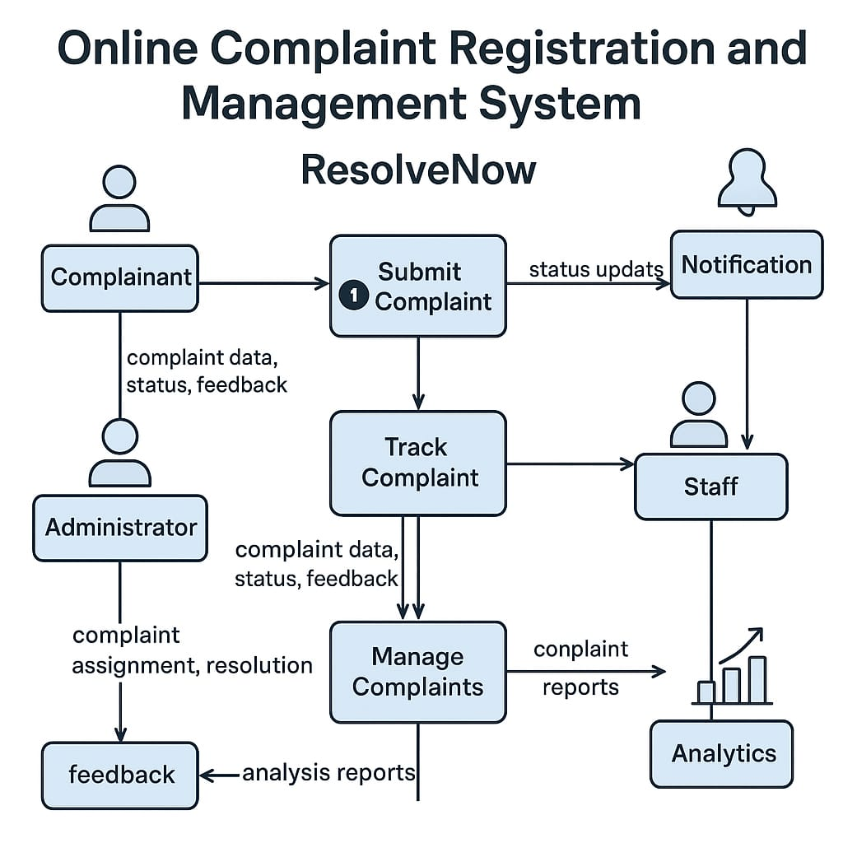

**User Story Table – Freelance Finder**

|  |  |  |  |  |  |
| --- | --- | --- | --- | --- | --- |
| **User Type** | **Functional Requirement (Epic)** | **User Story / Task** | **Acceptance Criteria** | **Priority** | **Release** |
| **Client** | |  | | --- | |  |  |  | | --- | | Query Posting | | As a client, I can post a Complaint. | Query appears on home page of the agent. | High | Sprint-1 |
| **Agent** | User Query | |  | | --- | | As an Agent, I will handle the queries. | | Application visible to client. | High | Sprint-1 |
| **User** | Messaging | As a user, I can chat with the other party in real-time. | Messages appear instantly. | Medium | Sprint-2 |
| **Client** | Payment Processing | As a client, I can successfully register my complaints. | Agent will receive the queries. | High | Sprint-2 |
| **Admin** | User Moderation | As an admin, I can review reported users and take action. | Reports and actions logged. | High | Sprint-1 |